➢➢ Explanation :
- Consider that a block of N words is present. Now we have to arrange these N words in ascending order, Let N = 4 for example. We will use HL as pointer to point the block of N words.
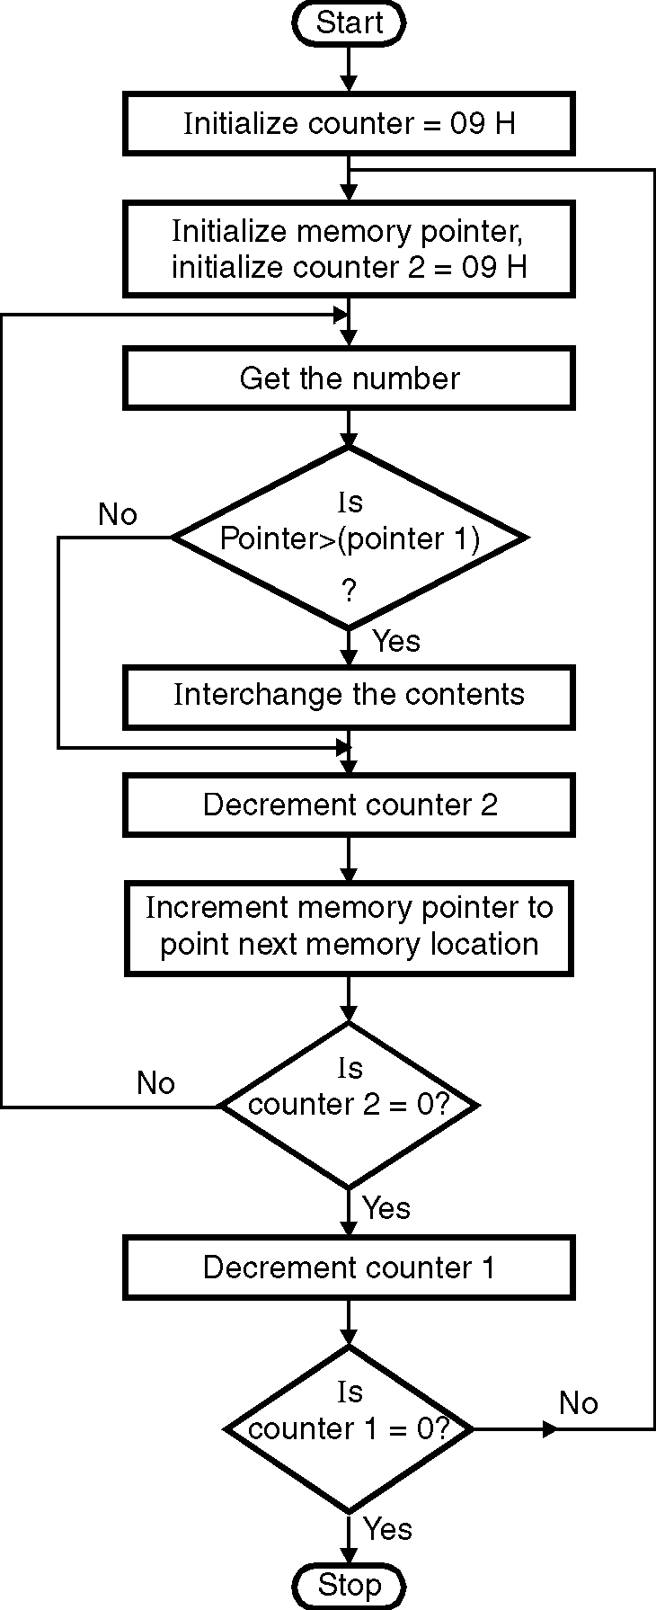
- Initially in the first iteration we compare first number with the second number. If first number < second number, don’t interchange the contents, otherwise if first number > second number swap the contents.
- In the next iteration we go on comparing the first number with third number. If first number < third number, don’t interchange the contents. If first number > third number then swapping will be done.
- Since the first two numbers are in ascending order the third number will go to first place, first number in second place and second number will come in third place in the second iteration only if first number > third number.
- In the next iteration first number is compared with fourth number. So comparisons are done till all N numbers are arranged in ascending order. This method requires approximately n comparisons.
➢➢ Algorithm :
Step I : Initialize the number of elements counter.
Step II : Initialize the number of comparisons counter.
Step III : Compare the elements. If first element
< second element goto step VIII else
goto step V.
Step IV : Swap the elements.
Step V : Decrement the comparison counter.
Step VI : Is count = 0 ? if yes goto step VIII else
goto step IV.
Step VII : Insert the number in proper position
Step VIII : Increment the number of elements counter.
Step IX : Is count = N ? If yes, goto step XI else goto step II
Step X : Store the result.
Step XI : Stop.
➢➢ Flowchart : Refer flowchart 17.
Flowchart 17
➢➢ Program :
Instruction Comment
MVI B, 09 ; Initialize counter 1
START: LXI H, D000H ; Initialize memory pointer
MVI C, 09H ; Initialize counter 2
BACK: MOV A, M ; Get the number in accumulator
INX H ; Increment memory pointer
CMP M ; Compare number with next number
JC SKIP ; If less, don’t interchange
JZ SKIP ; If equal, don’t interchange
MOV D, M ; Otherwise swap the contents
MOV M, A
DCX H ; Interchange numbers
MOV M, D
INX H ; Increment pointer to next memory location
SKIP: DCR C ; Decrement counter 2
JNZ BACK ; If not zero, repeat
DCR B ; Decrement counter 1
JNZ START ; If not zero, repeat
HLT ; Terminate program execution

